**Image Classification**

Dataset used: Fashion MNIST Dataset

I/P image size: 28*28 =784 bytes (grey scale values)

Items of Clothing dataset contains;

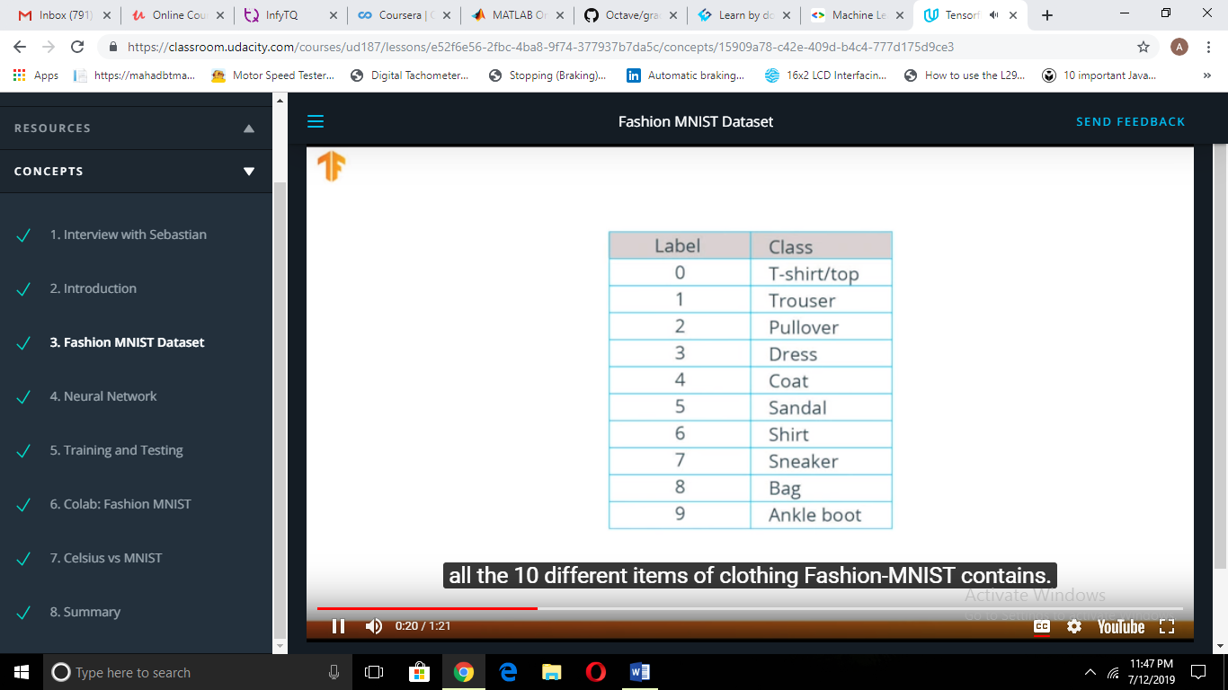

Avl Images: 70,000=60000(training set)+ 10000(testing set)

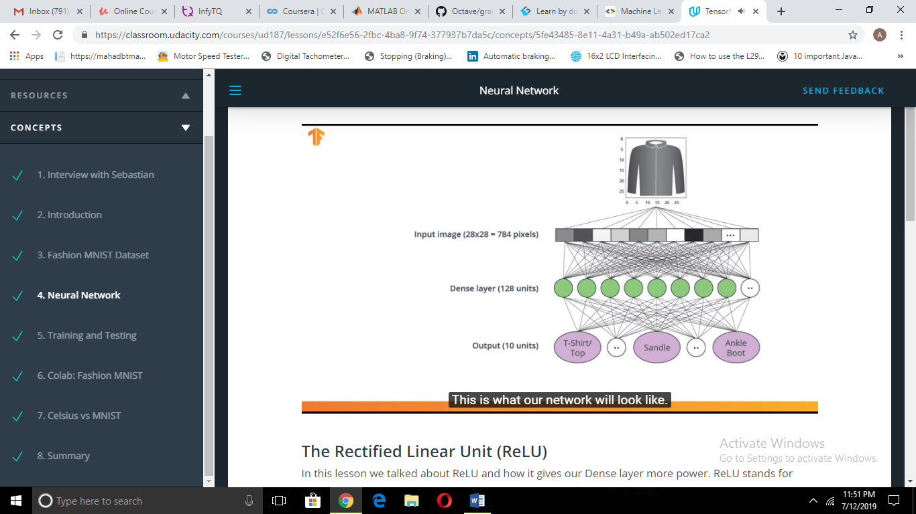

Deep neural network is built for training. This model accepts an array of size 784 as input.

But, since the image is of size 28x28,we need to restructure the 2D data into a 1D array .The process of doing this is called flattening which is achieved by using a flattened layer.

tf.keras.layers.flatten(input_shape=(28,28,1))

This input is then connected to a dense layer(of 128 units ,here.) Activation function- **ReLU, a mathematical function**  gives more power to this layer .

Tf.keras.layers.Dense(128,activation=tf.nn.relu)

ReLU –Rectified Linear Unit gives o/p zero for negative i/p and positive and equal to i/p for positive i/p which gives a network ability to solve non-linear problems.

Other terms:

Softmax: A function that provides probabilities for each possible output class

Classification: A machine learning model used for distinguishing among two or more output categories

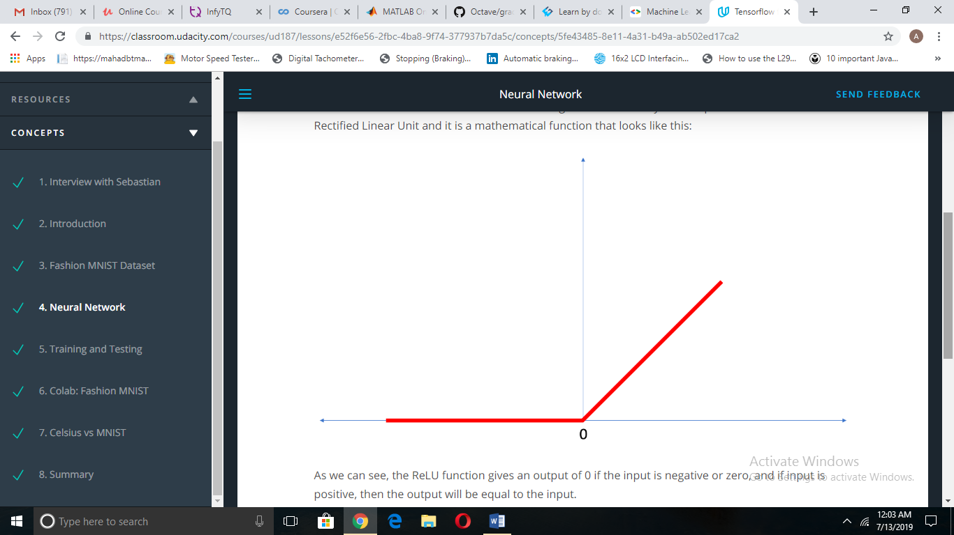

Finally , the last layer contains 10 units because we have 10 classes /types of clothing items.

Datasets are typically split into different subsets to be used at various stages of training and evaluation of the neural network.

Training Set: The data used for training the neural network.

Test set: The data used for testing the final performance of our neural network.

The test dataset was used to try the network on data it has never seen before. This enables us to see how the model generalizes beyond what it has seen during training, and that it has not simply memorized the training examples.

In the same way, it is common to use what is called a Validation dataset. This dataset is not used for training. Instead, it it used to test the model during training. This is done after some set number of training steps, and gives us an indication of how the training is progressing. For example, if the loss is being reduced during training, but accuracy deteriorates on the validation set, that is an indication that the model is memorizing the test set.

The validation set is used again when training is complete to measure the final accuracy of the model.